Footer

Back to Top button (icon) (fixed?)

Image

(30% width? of page)

(add padding, so image isn’t too close to text?)

Text

(70% width of page?)

(wrap text around image)

Navigation Bar (not fixed?)

Title of Website

(not fixed?)

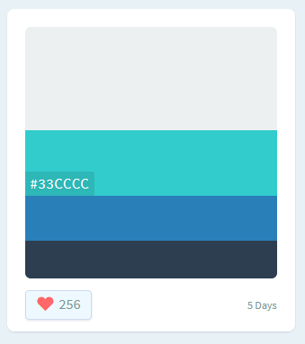Color Palette (www.colorhunt.co)

#ecf0f1 (bg?)

#33cccc (active?)

#2980b9 (button?)

#2c3e50 (text?)